POSTGRADUATE THESIS

Department of Physics

NED University of Engineering and Technology




[Title of the Thesis]

Submitted by
[Name of Student]
[Seat Number]

Supervisor
[Name of Thesis Supervisor]
[Name of Institute: NED University of Engineering & Technology]

Co-Supervisor
[Name of Thesis Co-Supervisor]
[Name of Institute: NED University of Engineering & Technology]

© NED University of Engineering & Technology. All Rights Reserved-[Month.Year]

Author’s Declaration

We declare that we are the sole authors of this thesis. It is the actual copy of the thesis that was accepted by our supervisor(s) including any necessary revisions. We also grant NED University of Engineering and Technology permission to reproduce and distribute electronic or paper copies of this thesis.

Signature and Date

.................................

[Name of Student]
[Seat Number]
[Email address]

Acknowledgments

[Write the acknowledgments here. Use single-spacing between lines. You can acknowledge any faculty member, any national or international organization, or sponsor for helping you out in completion of this thesis. They may have provided you valuable resources in the form of data, personal experience, disciplinary expertise, instruments, or technical support. Ideally it should be one or two short paragraphs.]

Dedication [Optional]

[Write dedication here. You may want to dedicate this work to immediate family members or members of a board or society that works for your cause. Ideally, it should be only one or two lines in length. However, if you do not wish to include a dedication, delete this page. After deleting this page and updating the table of contents, this page will automatically disappear from the table of content. In case, you have decided to delete this page, the table of contents should begin from page v.]

Table of Contents
Contents
1. Introduction 17
1.1 Background Information 17
1.2 Significance and Motivation 17
1.2.1 Heading of Subsections in Section 17
1.3 Aims and Objectives 17
1.4 Methodology 17
1.5 Report Outline 17
2. Literature Review 17
2.1 Introduction 17
2.2 [Title of the Section] 17
2.3 [Title of the Section] 18
2.4 More Sections 19
3. [Name of the Chapter] 20
3.1 Introduction 20
4. [Name of the Chapter] 21
4.1 Introduction 21
5. [Name of the Chapter] 22
5.1 Conclusion 22
5.2 Recommendations for Future Work 22
6. References 24

List of Figures
Figure 1: Trend of Monthly Average High and Low Temperatures in Karachi (Shepherd, 1956) 4

List of Tables
Table 1: Residual Stresses for a Plate 4

List of Abbreviations

FPC Flat Plate Collector

TSS Tubular Solar Still

EPBP Economic Payback Period

List of Symbols

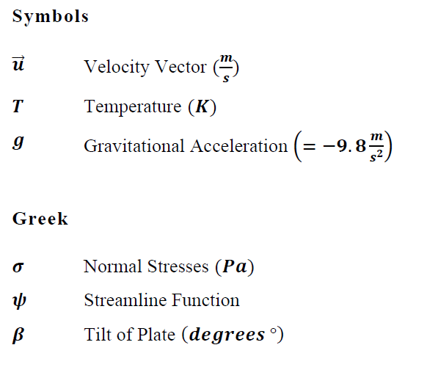

United Nations Sustainable Development Goals

The Sustainable Development Goals (SDGs) are the blueprint to achieve a better and more sustainable future for all. They address the global challenges we face, including poverty, inequality, climate change, environmental degradation, peace and justice. There is a total of 17 SDGs as mentioned below. Check the appropriate SDGs related to the project.

- No Poverty

- Zero Hunger

- Good Health and Well being

- Quality Education

- Gender Equality

- Clean Water and Sanitation

- Affordable and Clean Energy

- Decent Work and Economic Growth

- Industry, Innovation and Infrastructure

- Reduced Inequalities

- Sustainable Cities and Communities

- Responsible Consumption and Production

- Climate Action

- Life Below Water

- Life on Land

- Peace and Justice and Strong Institutions

- Partnerships to Achieve the Goals

Justification of SDG Mapping

[write one paragraph to justify how you work mapped with the SDG/SDGs ]

Certificate

The following student have compiled the thesis on the topic given below for partial fulfillment of the requirement for Masters’s degree in Physics.

Thesis Title

[Student Name] |  | [Seat Number] | Signature

This is to certify that Plagiarism test was conducted on complete report, and overall similarity index was found to be less than 20%, with maximum 5% from single source, as required.

…………………… ……………………

Co-Supervisor Supervisor

[Name of Co-Supervisor] [Name of Supervisor]

[Attach here the 3 pages of the plagiarism report generated by Turnitin. Sample is given]




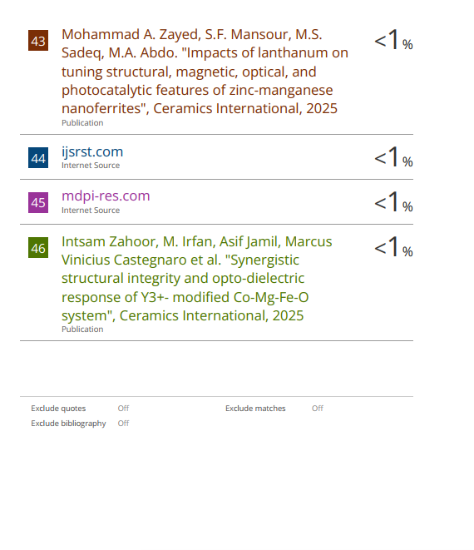

Abstract

Note: Number of Chapters and their Names may very from topic to topic

Chapter 1

Introduction

Background Information

A thesis usually contains five or six chapters. Chapters should be divided into sections that should be numbered according to their chapter numbers. For instance, the numbering of sections of chapter one should be 1.1, 1.2, 1.3, etc.

The first chapter should be “Introduction” and it should provide the background information related to the thesis. The first section of the Introduction chapter should be titled “Background Information”. While the other sections should be “Significance and Motivation”, “Aims and Objectives”, “Methodology” and “Report Outline/Scope” of the Thesis. It should inform the readers what you did in the thesis, why you did it, and how you achieved it. This chapter provides a broad overview on what is discussed in the report.

Significance and Motivation

The second section of the chapter one should be “Significance and Motivation”. It should include the importance of the thesis and its benefits.

Subsections should have numbering in accordance with its chapter and section number. For example, the numbering of subsections in section two of chapter one should be like 1.2.1, 1.2.2, 1.2.3, etc. It is not recommended to have only a single subsection in a section.

Heading of Subsections in Section

Heading of Subsections of subsection in Section if required
vjkljkcx

Aims and Objectives

The third section of the chapter one should be “Aims and Objectives”.

Methodology

The fourth section of the chapter one should be “Methodology”. It should include the details of the methodology that you have used to solve the problem.

Report Outline

The fifth section of the chapter one should be “Report Outline”. It should include the scope of the thesis and explain the general outline of the report by highlighting the content that is covered in different chapters and sections.

Kindly include more sections in the Introduction chapter if you prefer.

Chapter 2

Literature Review

Introduction

Except for the Introduction chapter (first chapter) and the Conclusion chapter (last chapter), all other chapters should have first section titled “Introduction” and last section titled “Summary/Conclusions”. In Introduction sections, discuss the content of chapters such that the readers will have an idea about what is discussed in the chapters. This allows the readers to know in advance if the chapter is relevant to their interests. On the other hand, the Summary sections discuss what has been achieved in the chapters. Write the Summary sections by keeping in mind that many readers do not have time to read the complete chapters; therefore, they only read Summary sections to get an overview. Consequently, include the most important achievements and aspects in these sections and use past tense to write Summary sections.

The goal of this chapter is you discuss how your work is different from the work already done in the field. You should present a critical review on the past work on your topic. This chapter will in return help students to gather updated knowledge on the thesis and this will enable them to understand the limitations of previous work done on your topic.

[Title of the Section]

A sample graph is shown in the Figure ‎2.1. Always use the “Insert Caption” option to insert the figure label and numbering automatically. This will also automatically update them in the List of Figures. Captions of figures should be given on the bottom of the figures. To refer to a figure in the text go to References in the Ribbon, then click on Cross-reference, then select Figure in Reference type, then select Only label and number in Insert reference to.
Shown in Figure ‎2.2

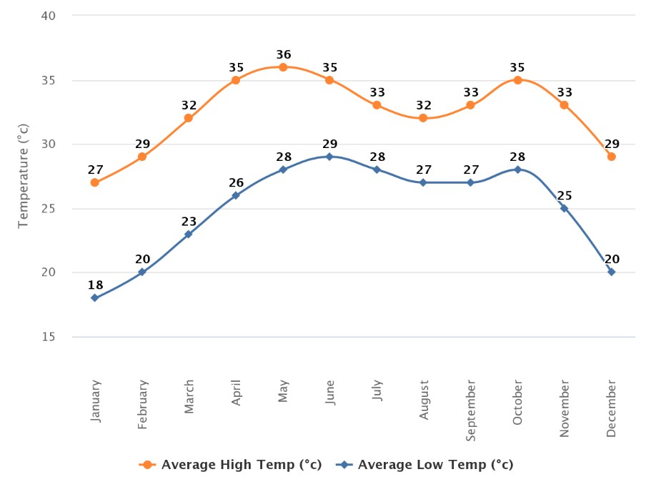
Figure ‎2.1 Trend of Monthly Average High and Low Temperatures in Karachi (Shepherd, 1956)

Figure ‎2.2 abc

[Title of the Section]

A sample table is shown in the Table 1. Always use the “Insert Caption” option to insert the figure label and numbering automatically. This will also automatically update them in the List of Figures. Captions of tables should be given on the top of the tables. To refer to a table in the text go to References in the Ribbon, then click on Cross-reference, then select Table in Reference type, then select Only label and number in Insert reference to.

Table ‎2.1 Residual Stresses for a Plate
Orientation | 𝝈�(𝑴𝑷𝒂) | 𝝈�(𝑴𝑷𝒂) | 𝝉��(𝑴𝑷𝒂) | 𝝉��(𝑴𝑷𝒂) | 𝝉��(𝑴𝑷𝒂)
0° | -0.282 | -0.143 | 0 | 0 | 0
90° | 0.282 | 0.143 | 0 | 0 | 0

More Sections

Include sections as appropriate to your literature review.

Chapter 3

[Name of the Chapter]

Introduction

Include more chapters as appropriate to your thesis. All chapters should start from a new page. The middle chapters should discuss your work on the thesis. Some famous headings for these chapters are Design and Calculations, Modeling and Simulations, Fabrication Work, Data Acquisition and Analysis, Comparison of Methods, Results, Discussion/Interpretation of Results, etc.

Chapter 4

[Name of the Chapter]

Introduction

More chapters.

Chapter 5

[Name of the Chapter]

Conclusion

The last chapter should be “Conclusions”. It is ideally the fourth or fifth section of the report. This chapter should include the aims and objectives of the thesis. It should also summarize the important points in the previous chapters, and the findings and achievements of your thesis. If possible, write some recommended future work on the thesis based in your conclusions. Therefore, the last section of this chapter should ideally be “Recommendations”. For example, you may provide recommendations by discussing constraints of your thesis and ideas to eliminate them. You may also highlight other possible investigations to improve the efficiency of your thesis. Use present perfect tense to write the conclusions. The recommended two sections for the Conclusions chapter are “Summary” and “Recommendations for Future Work”.
Do not use cross referencing, external references, or footnotes in the Conclusions chapter. Make it a stand-alone chapter.

Recommendations for Future Work

Write details here.

Appendix A

[Title of Appendix]

Include appendices, if applicable. Appendices should include the information that is not the primary part of the main body of the thesis. This means that if this information is removed from the main body, it would not negatively affect the flow of ideas in the main body of the report. For example, it may include long computer programming codes while keeping a flow chart of the code in the main body of the report. It may also include lengthy numerical data while keeping their graphs in the main body of the report.

If the thesis has only one appendix, then the label of this chapter should be “Appendix” (not “Appendix A”). To cite an appendix in the text, write full title of the appendix that is “Appendix A”, “Appendix B”, etc. Each appendix should start from a new page and should also include a short description of what is included in that appendix.

References

Shepherd, D. G. (1956). Performance of one-row tube coils with thin-plate fins, low velocity forced convection. Heating, Piping Air Cond, 28, 137-144.

Glossary [Optional]

Term | Definition | [Page at which it  first appeared]
Azimuth angle between North, measured clockwise around the Pg. 1

observer's horizon and sun

Zenith an imaginary point directly above the observer/system, complement of altitude angle

Pg. 5

